SPUD LICIOUS BAR
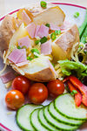  Healthy Tasty Jacket Potato Fillings  Cold Fillings :  Cheese  Allergens MILK  Coleslaw  Allergens EGG,  Tuna Mayo  Allergens FISH, EGG |  |  | Jacket Potato with One Filling £1.60  Side Salad 40p  Extra Topping 60p  *Menu Subject to Change*  S  Hot Fillings:  Baked Beans  Allergens  Chicken Curry  Allergens MILK, MUSTARD, NUTS  Chilli con Carne  Allergen

