

Highworth Warneford School Teaching & Learning Policy

2025-2026



Rationale
Highworth Warneford School is committed to using and promoting engaging and effective teaching and learning strategies, which meet the need of all its pupils of all abilities. We are committed to teaching lessons which challenge all students and allow them to make progress. It is really important that we also develop the skills that all students will need in order to retain and recall information that they can then apply to different situations. We are committed to providing and developing creative and engaging learning activities to enhance the learning experience.
Overview
All of our teachers are trained to TEEP Level 1 standard. TEEP presents a framework for teaching and a common language of learning to enhance consistency in teaching and learning approaches throughout the school. We expect teachers to plan their lessons using the TEEP learning cycle and follow our CREATE prompts to ensure lessons are incorporating the TPAT Principles into their practice.

TEEP (Teacher Effectiveness Enhancement Programme)

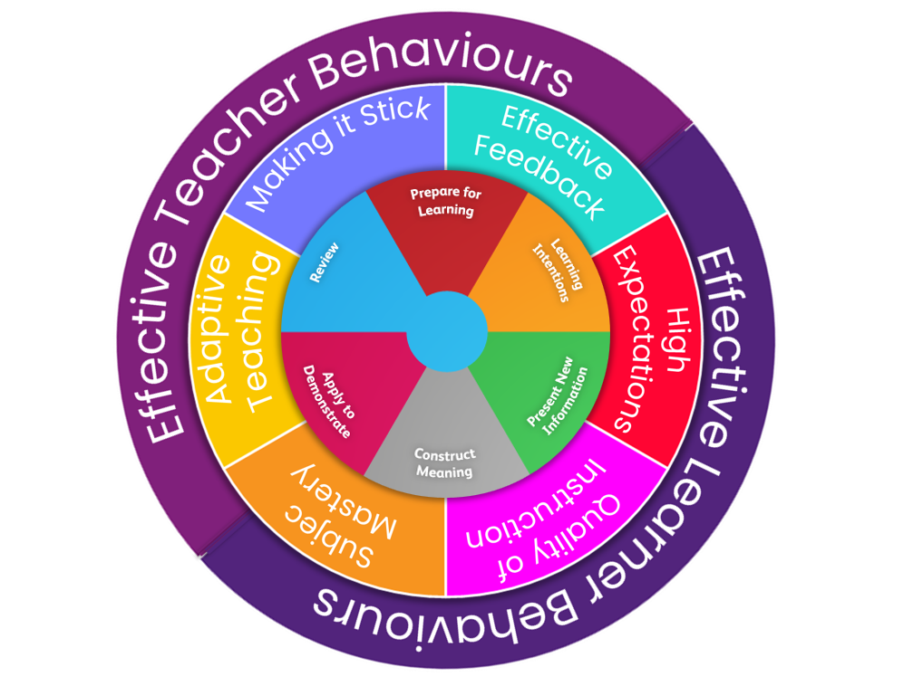

Lesson Structure
This is a process for teaching that structures the key components of an effective lesson in a clear form for teachers and pupils.
Prepare for learning: Teachers will strategically work with their pupils to develop a climate that is conducive to learning. This includes the physical environment – classrooms to be organised and inviting, the social environment – pupils feeling supported within the class and group dynamics and the intellectual environment – ensuring that challenge is set from the outset. Teachers to access to identify and cater for individual pupil learning needs e.g., disadvantaged, SEND, Higher Prior attainment. This information is also used to inform seating plans and groups for collaborative work.
Agree learning outcomes: Teachers explicitly share the purpose of the lesson/s with their pupils so that the pupils are in no doubt as to what is expected of them during the lesson. Pupil engagement is key for the success of this component as this is essential to the pupils fully understanding and identifying their next steps for learning.
Present new information: At this stage pupils will be presented with or introduced to the new information that they are required work with. Teachers are encouraged to present this in a variety of ways to enhance the learning and pupil interaction with this information.
Construct meaning: Pupils are given the time and opportunity to develop understanding of the new information and to practise using their developing skills. The pupils are actively engaged in exploring the content allowing for independent learning.
Apply to demonstrate: Pupils participate in tasks that will allow them to demonstrate their developing understanding of the content that was presented. During this time teachers and pupils may be involved in assessing and evaluating the outcomes of the learning.
Review: Reviewing is a critical element in the process of teaching and learning as it challenges the pupil to make their learning explicit. Although review is the last of the elements of the cycle, it should not be seen as coming only at the end of a lesson. It is useful to include different review opportunities throughout every lesson so that teachers and pupils can identify and challenge strengths and weaknesses, identifying the next steps of the personal learning process for each pupil. Review is a significant part of developing metacognitive awareness, allowing pupils to think about their learning process and what knowledge they have gained and apply this to their work.
Staff may use the HWS linear lesson plan proforma or the HWS 5-minute lesson plan proforma to help them consider elements of CREATE and incorporate the TEEP Cycle into their lesson planning.

Underlying Principles for Effective Teaching
Excellent learning takes place as a result of excellent teaching. At TPAT we work as a team across our Trust to continually develop our expertise as masters of our craft in the classroom. As a result, over time we have codified our practice into the TPAT Learning Principles. These are the pedagogical elements that are embedded throughout all lessons and enhance pupils understanding.



To help embed consistency of applying the TPAT Principles across the school, we have used the acronym CREATE: Challenge, Retrieval, Explicit Intentions, Assessment/Feedback, Thinking and Engage and a series of ‘bookmarks’ to act as prompts; ensuring teachers are incorporating evidence-based pedagogy into their practice and allowing school leaders to emphasise the key priorities for the school, while maintaining a common language
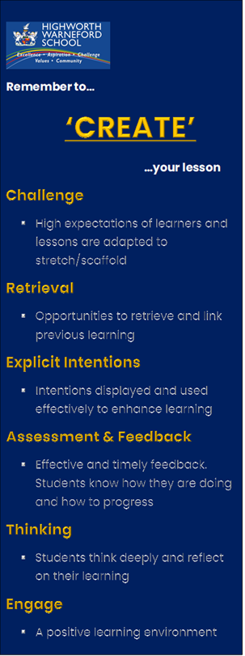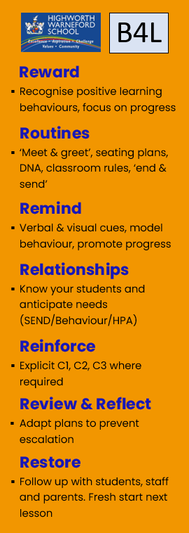
CREATE Bookmark
B4L Bookmark

- High Expectations of Learning Behaviour (Engage)
Teachers are responsible for promoting a positive learning environment. Classrooms should be organised and inviting. Displays should be considered and aid learning rather than be over-stimulating. Learning tasks should be varied and interactive where appropriate. Teachers should implement routines and teaching methods that increase participation and ensure all students are engaged in the learning. All lessons must start with a ‘Do Now Activity’ which is ready for students to complete on entry. This will mostly be a low stakes retrieval task that students will complete on the mini whiteboard. This provides a calm and purposeful start to the lesson; allowing the teacher to meet students at the door, complete the register and monitor engagement levels.
Building positive relationships with students should be the priority for all teaching staff. We have high expectations of our students but we provide high support to ensure they can meet them. Students who demonstrate integrity and challenge themselves should be recognised and rewarded. Teachers should respond to challenging behaviour in a proactive way that minimises disruption to lessons and allows students to learn. The B4L policy should be implemented and class charts used as a tool to respond to behaviours and keep pastoral team / parents informed. Book work must represent excellence and follow our PUSH guidelines:

“Strong relationships with teachers and school staff can dramatically enhance students’ level of motivation and therefore promote learning. Students who have access to more strong relationships are more academically engaged, have stronger social skills, and experience more positive behaviour”.
The Education Trust

- Quality of Instruction (Explicit Intentions)
Defined learning intentions must begin with specific TPAT taxonomy and be displayed throughout the lesson. All students should be working towards the same high expectations so learning intentions should not be differentiated. They should be agreed with students and referred to regularly to enhance learning. This allows students to understand how each activity contributes towards the learning intentions and take ownership over their progress during the lesson. It helps them to connect new knowledge to existing schemas and identify where there learning sits within the ‘bigger picture’.
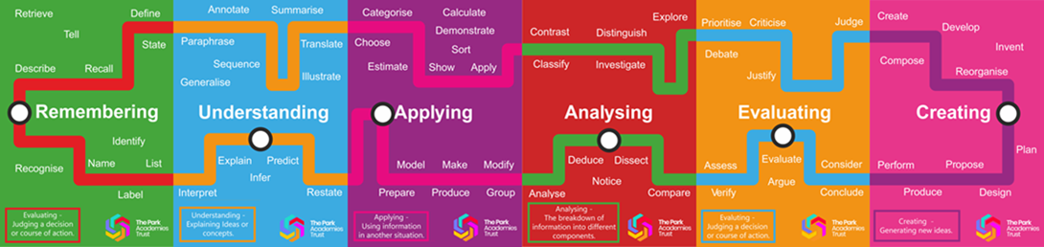
Teachers should model excellence in how they present new information and give highly effective explanations, while skilfully minimising cognitive load. Teachers must use a range of questioning techniques to ensure every student has the opportunity—and expectation—to think, participate, and succeed. Rather than choosing students with hands-up to respond, these strategies’ structure participation so that all students are held accountable for thinking and supported in sharing their ideas. When every student is prompted to engage—rather than just a few—we increase the likelihood of learning “sticking,” expose gaps in understanding, and gather the evidence needed to adapt instruction in real time.

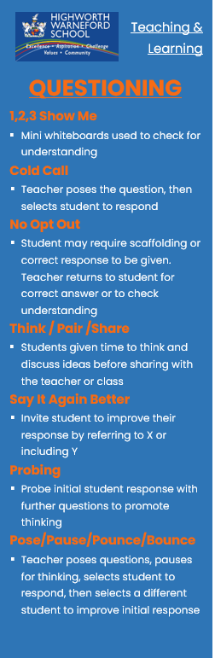
“Effective questioning is a powerful instructional tool that promotes critical thinking, active participation, and deeper understanding among students.”
Ross Morrison McGill

Questioning Bookmark

- Subject Mastery (Thinking)
Our teachers are subject specialists and should model excellence in their field; continuously prioritising their own subject knowledge development. This ensures teachers are capable of engaging students in the wider world, make links to further learning and spark interest in relevant future careers. Teachers should uphold the highest levels of literacy and oracy; exposing students to high quality topic texts and expert level examples of work they can aspire to. Lesson activities and teacher questioning must engage students in challenge and make them think hard. The most effective teachers are able to model metacognitive thinking and encourage students to plan, monitor and evaluate their own learning. We expect teachers to show expertise in specification for the GCSE and /or key stage; planning to address common misconceptions and explicitly developing the skills required for students to be successful in exams.
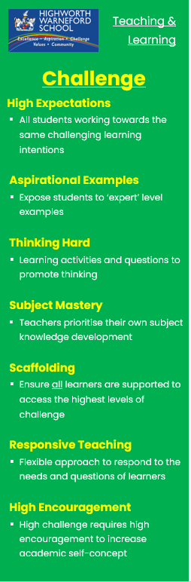
Challenge Bookmark
“Learning happens when people have to think hard”
Prof. Robert Coe

- Adaptive Teaching (Challenge)
Our school is an inclusive, comprehensive environment which challenges all learners to make the most progress. We expect teachers to have a good understanding of student context and prior attainment; identify students with SEND, be familiar with their specific needs and use the supportive strategies described in their Pupil Passport.
Teachers must plan lessons with a high level of challenge but anticipate the needs of individual students in their class and plan to scaffold the learning appropriately. Scaffolding techniques like modelling (I do, we do, you do), use of writing supports and task planners should be a regular feature of lessons. Teachers should use targeted questioning techniques to check for understanding throughout the lesson and respond to any emerging learning needs, by adapting the lesson or learning activity.
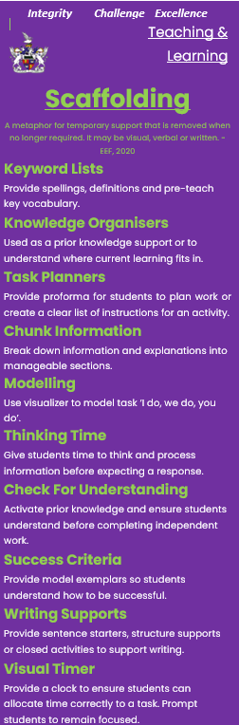
Scaffolding Bookmark
“Adaptive teaching is about all students working on the same tasks and towards the same challenging outcomes”
Alex Quigley

- Making it Stick (Retrieval)
After delivering new information to learners, teachers must ensure they can retain and recall it by providing regular opportunities to practice retrieving knowledge. Actively recalling information, rather than passively reviewing it, interrupts the forgetting process and strengthens memory. Retrieval practice is not an assessment. Instead, it may take the form of a low stakes quiz or knowledge dump. Material should be revisited at progressively longer intervals and topics should be interleaved with each other. In our school, most ‘Do Now Activities’ will provide the perfect opportunity for low stakes retrieval, using mini whiteboards.
When preparing for exams, students should be explicitly taught how to revise in your subject area and given specific revision tasks rather than generic instructions to revise.
“Practising remembering” is at the very core of what effective learning is about. The more we know, the more we can know. The more we know, the more we understand. The more often we retrieve knowledge from our vast complex stores of memories in different ways, the stronger those memories become and the more fluently we can recall them”.
Tom Sherrington

- Effective Feedback (Assessment & Feedback)
Effective feedback is vital for students to make meaningful progress in their learning journey. It is our way of checking that the knowledge they are gaining is both accurate and complete. Every lesson, teachers are expected to implement formative assessment techniques to check for understanding and respond to emerging needs. Verbal feedback will be a feature of most lessons and students are expected to proactively respond to this feedback. Students should be taught skills to self-assess and peer-assess confidently, regularly evaluating their knowledge against Personal Learning Checklists (PLCs).
Every department has a milestone assessment plan, ensuring all students receive regular written feedback which allows them to make progress. Teachers are expected to follow their department assessment plan and give feedback in the form of WWW / HTI / MAC. Any written teacher comments must be completed in red pen and students should be given time to complete MAC tasks using green pen.
After summative assessments, question level analysis should be used to identify knowledge gaps and identify misconceptions. Teachers should re-teach content that students do not yet understand and then re-test to ensure students are ready for the next phase of learning.
“(Feedback)…done well, it supports pupil progress, building learning, addressing misunderstandings, and thereby closing the gap between where a pupil is and where the teacher wants them to be”.
EEF

Monitoring of the Teaching and Learning Policy
Monitoring of the effectiveness of the T&L policy will be completed throughout a variety of processes including:
SLT / Curriculum Leader / Pastoral Leader Learning Walks
Termly learning walks with an agreed general focus. Whole school and department level feedback given
T&L Review Cycle
Three lesson observations per year within a specified period of time. Each teacher receives developmental 1:1 feedback; reviewing each of the TPAT Principles and agreeing a MAC target where appropriate.
Performance Management
All teachers have a yearly T&L target, linked to a specified TPAT Principle, for personal development throughout the year. These targets are supported through CPD, TPAT collaboration and coaching.
Work Scrutiny / Book Looks
Termly book looks by Curriculum Leaders to monitor consistency of experience between classes in a year group.
Termly work scrutiny by SLT and Curriculum Leaders to monitor standards of work, quality of assessment and feedback and level of challenge.
Pupil Voice
Questionnaires / interviews completed throughout the year with a specific focus.
External Monitoring
Monitoring visits by School Improvement Partners and/or TPAT staff will take place at regular intervals throughout the year.
Parental Voice
Questionnaires are completed to record parental opinion about T&L and homework.
Teacher Voice
Questionnaires and feedback.

